Impact of lockdown measures during COVID-19 on air quality

# *Garvit Jain , Ishu Kumar , Hittesh Mittal , Mohit Bhajpai*

## UG Scholar , UG Scholar , Assistant Professor Department of Computer Engineering

Poornima Institute of Engineering and Technology, Jaipur

*ABSTRACT:-*

A novel coronavirus disease (COVID-19) identified as a Global Pandemic by World Health Organization (WHO).COVID-19 has impacts on the Natural Environment. From COVID-19 the entire India is cleared by air pollution. The Goverment has decided to set the Data Tracker in the cities where pollution is increasing day-by-day and the work of data tracker is to be measuring of many type of gases like NO2 ,CO2 etc. in the Cities. Before lockdown the Government of India is expecting that the cases of air pollution is to be very high to this year From the past year.From lockdown the air pollution cases is lower then excepting. From lockdown the effect in Pollution is described in Table1:-

*Table -1*

|  |  |  |  |  |
| --- | --- | --- | --- | --- |
| *Gases* | PM**10** | PM**2.5** | NO**2** | SO**2** |
| *Pre****-****Lockdown* | **55%** | **49%** | **60%** | **19%,** |
| *Post****-****Lockdown* | **44%,** | **37%** | **78%** | **39%** |

# *Introduction:-*

## COVID-19 is one of the major disaster, which has impacted the whole world. In response to the COVID-19, The Indian Prime Minister announced Janata (people’s) curfew on 22 March 2020 from 7 am until 9 pm. Because of COVID-19 The Government of India announced a complete Nationwide lockdown. All the Domestic and International Flights, Trains, and Vehicular Transport except for non-essential purposes were stopped. This decision impacts poor people and migrant workers in the major cities Delhi and Mumbai. These migrant workers had daily wages and without any Job. It was difficult for them to survive. The Northern parts of India are subjected to poor air quality and atmospheric pollution, Because of the emissions from Vehicles, Industry, Brick kilns, Coal-based power plants, Crop residue burning, etc. The capital of India New Delhi suffers from sustained poor air quality where pollution levels are high. Whereas in India, the poor air quality has continuously increased over the last several decades associated with growing artificial activities. Because of the increase of air pollution day by day, the Delhi Government conducted experiments of Permitting odd or even licensed vehicles on the road to control the pollution level. But these experiments have generally not helped or improved the air quality of Delhi. During lockdown in India, roads were deserted without any vehicle except the emergency vehicles. The month of April is the peak time of winter crop harvesting (wheat) and planting of vegetables in India, so the Government relaxed the movement of farmers from lockdown in the second phase. The Government of India has extended lockdown in some parts in a Relaxed Manner. Now the Government has opened Vehicular transport, Domestic flights, and Few trains, as a result, the air quality is getting poor. Because farmers at many places had started the burning of crop

residue and long-term transport of dust. During the Pre-monsoon season, the Government was observing that how pollution getting affects the air quality in Delhi and many other cities located in the Indo-Gangetic Plains (IGP). Recently, considered The Central Pollution Control Board Dataset and studied the impact of lockdown on air quality for the Period. This paper aims to study the impact of a complete lockdown in India on air quality (PM2.5, AQI, and NO2) during COVID-19 by comparing air quality parameters during March 2019 and 2020.

*Data:-*

*For our study, we have considered major cities, Delhi, Kolkata, Mumbai, Chennai, and Hyderabad, where US embassies are located. The details of US embassies are given in Table-2-:-*

*Table -2*

|  |  |  |  |
| --- | --- | --- | --- |
| Station Name | Latitude | Longitude | Coordinates for NO2 data from OMI satellite |
| Delhi | 28.59 | 77.18 | W-76.68, S-28.07, E-77.68, N-29.07 |
| Kolkata | 22.54 | 88.35 | W-87.86, S-22.08, E-88.86, N-23.08 |
| Mumbai | 19.06 | 72.86 | W-72.42, S-18.55, E-73.42, N-19.55 |
| Hyderabad | 17.44 | 78.47 | W-77.78, S-17.01, E-78.78, N-18.01 |
| Chennai | 13.05 | 80.25 | W-79.76, S-12.56, E-80.76, N-13.56 |

# *PM2.5 data:-*

The US embassies are located in five major metropolitan cities in India, New Delhi had 30 million population, Mumbai had 25 million population, Hyderabad had 12.91 million population, Kolkata had 15.6 million population and Chennai had 10.96 million population are given as per the latest census. We have studied two primary air quality parameters:-

1. PM2.5 particulate matter with a particle size of 2.5-micron diameter and
2. Air Quality Index-AQI

Parameters are monitored by each respective US embassies at five locations. Data are taken from the US Environmental Protection Agency (EPA) through AirNow portal.

# *NO2 data:-*

We have considered tropospheric NO2, one of the major pollutants which is highly dependent on the local sources because of its short residential time in the atmosphere. We have considered tropospheric NO2 data from the Ozone Monitoring Instrument (OMI). OMI is part of the NASA A- train satellite missions, which measures the concentration of various trace gases in the atmosphere. We have used OMI version 3 data which has a 1-day temporal and 0.25°×0.25° spatial resolutions. The details of the data are discussed by B Krotkov et al. (2019). The data are downloaded through NASA Giovanni portal. US embassies in India selected a 1°×1° square box over the five US embassies to study the temporal variation of tropospheric NO2.

# *HYSPLIT Model:-*

We use the trajectory analysis over the major cities Delhi, Mumbai, Hyderabad, Chennai, and Kolkata. Using the NOAA HYSPLIT model to study the sources of air mass reaching at five locations. The back trajectories were analyzed for 100h to track the air mass reaching the measuring site. After every 6h, these trajectories are overlapped on the world Map.

# *Result & Disscussion* Figure-1:-

#### In Fig.1 shows the impact of complete lockdown in India, average PM2.5 concentrations during March 2020 and after lockdown period along with the average PM2.5 concentration during March 2019. The average concentration of PM2.5 before lockdown was higher in comparison with the concentration after lockdown. The PM2.5 concentration in Kolkata is reduced by 34.52%, and 27.57% in Delhi, capital of India. In general, PM2.5 is much higher throughout the year in the northern parts of India especially in the Indo-Gangetic Plains (IGP). During pre-monsoon , winter season, and crop residue burning seasons,

PM2.5 varies in a range of 400–800 μgm/m3. In Mumbai, Chennai, and Hyderabad, PM2.5

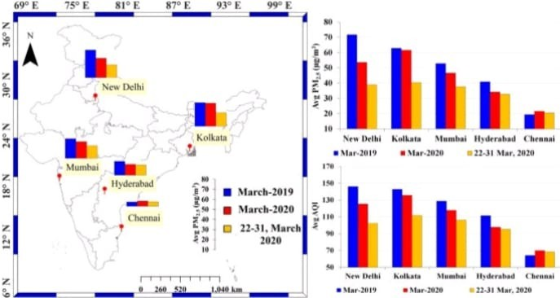was reduced by 19.25%, 5.40%, and 3.99%, respectively. The dominance of westerly wind from arid and semi arid region and lower temperature along the Indo-Gangetic plains in the month of March, the average concentration of PM2.5 remains higher in comparison to other cities. The proximity of Mumbai and Chennai to the sea, the air mass mostly reaches from the sea surface during March and the PM2.5, is lower in comparison with Delhi and Kolkata. Similar changes are also observed in the Air Quality Index (AQI) which is a function of PM2.5 and other emissions. The improvement in air quality is clearly observed mainly due to lockdown. This lockdown is now with little relaxation in some of the localities in cities where no case of COVID-19 was found. In India, complete lockdown was observed in a phased manner. We have considered data only for the phase 1 to avoid influence of crop harvesting, long range transport of dusts, and crop residue burning on the air quality in the month of April. and later months. We have carried out an analysis of air mass trajectory for four different time periods.

Fig.1

Left panel shows locations of five US Embassy (Delhi, Kolkata, Mumbai, Hyderabad, and Chennai) along with variations of average PM2.5 during March 2019 (blue bar), March 2020 (red bar), and average during 22–31 March 2020. The lower right panel shows the average AQI over New Delhi, Kolkata, Mumbai, Hyderabad, and Chennai for different periods. In general, PM2.5 and AQI are reduced during lockdown (22–31 March 2020) compared with March 2019 and March 2020, except in Chennai.

# *Figure-2:-*

In Fig.2 we have shown air mass back trajectories at five locations of US embassies during March for the years 2019 and 2020. The back trajectories provide details about the sources of air

mass reaching to five measurement locations. We have observed that Delhi is mostly influenced by western and north western air mass during March 2019 and 2020. Over Mumbai, the air mass is reaching from Northern India and also from the Arabian Peninsula during 2019, whereas in March 2020, first half, air mass is coming from the Arabian sea and surrounding regions, and during 2020, air mass is coming from Gujarat, Rajasthan and also from the Arabian Peninsula. In Hyderabad, during 2019 and 2020, the sources of air mass are different; during 2019, air mass is coming from the southern coastal region and western parts of India. But during 2020, air mass is coming from the Bay of Bengal before lockdown, and during lockdown, the air mass is coming from the Indo-Gangetic Plains and the Bay of Bengal Over Chennai, the air mass is reaching from the Bay of Bengal in the month of March 2019 and 2020, and during 2020, air mass is coming from the eastern parts of India and from the northern parts (IGP). Kolkata city is located in the eastern part of the Indo-Gangetic Plains and is mostly influenced by westerly air mass except 2019; in this period, air mass is coming from Hyderabad and the Odisha region. The HYSPLIT analysis clearly shows the influence of long-range transport of air mass over five different locations. The westerly air mass brings dust that affect the air quality (PM2.5 and AQI) of Delhi, and further, the dust is transported in the eastern parts of the Indo-Gangetic Plains affecting air quality of Kolkata city. Although this does not happen always, the transport of dust at Kolkata city depends on the wind velocity; The westerly air mass from IGP and long-range transport of air mass from southern India influence this city. At Hyderabad, the sources were different during 2019 and 2020. In Mumbai, mostly the air mass was northerly and westerly except when dominant air mass comes from the seaside. Chennai is mostly influenced by oceanic air mass. In Chennai, due to change in source of air mass, the average PM2.5 was lower during March 2019 compared with March 2020 and also during the lockdown period . The long-range transport of the air pollutants influences PM2.5 concentrations in Chennai during 2020; thus, a high value of PM2.5 was observed during March 2020.

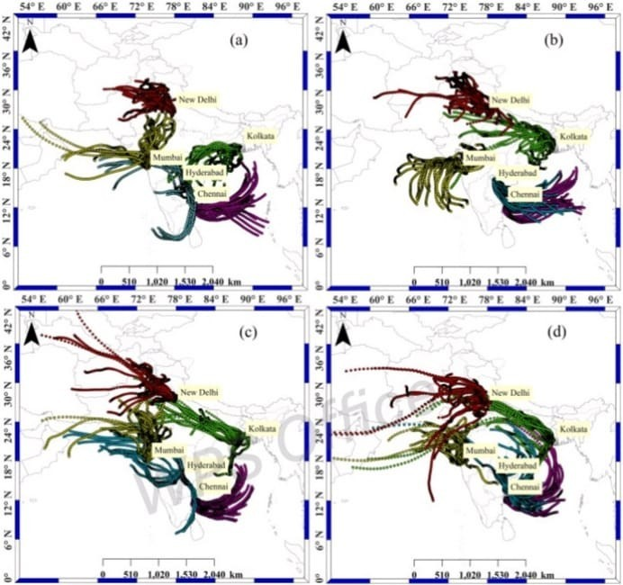

Fig.2

*HYSPLIT back trajectory over Delhi, Mumbai, Kolkata, Hyderabad, and Chennai during (a) 10–21 March 2019,*

*(b) 10–21 March 2020, (c) 22–31 March 2019, and (d) 22–31 March 2020*

# *Figure-3:-*

In Fig.3, we have shown tropospheric NO2 over India during March 2019 and 2020 for the periods in March. Over Delhi, Mumbai, and Kolkata cities, the main sources of the NO2 emissionsare anthropogenic during the month of March. Generally, in this month, biomass burning influences the

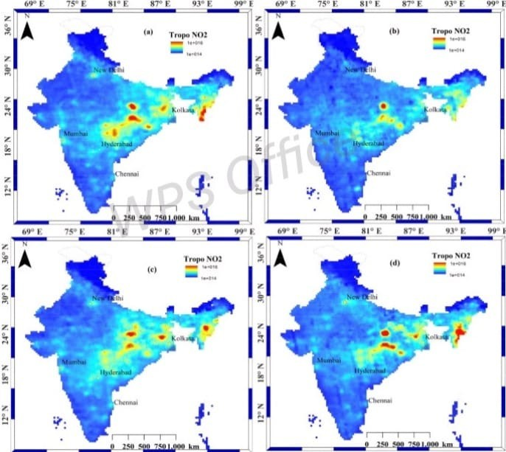southern parts of India. As a result, high NO2 concentration over Chennai and Hyderabad are observed that the fossil fuel consumption also adds to the pollution level. In central Indian states, Jharkhand and Odisha, coal-based power plant emissions are the major sources of tropospheric NO2. During March 2019, the average concentration of tropospheric NO2 is observed to be high during in most parts in India during 2019. In contrast, during the effect of lockdown is clearly observed in the average tropo-spheric NO2 concentrations in most parts of India. In Fig.3 a, band c, the National Capital Region (NCR), is the hotspot for NO2 concentrations in the northern parts, but during the lockdown period in the month of March 2020. In complete lockdown and closure of power plants, factories, vehicles, etc. are closed so, the NO2 hotspot is not seen at high values. In the month of March 2019, major NO2 hotspots are observed in Jharkhand, Odisha, and Eastern states. Higher values of tropospheric NO2 concentration is attributed to the dense coal-based power plants and forest fires in Jharkhand and Odisha, and in the Eastern states.

Fig.3

Spatial variations of tropospheric NO2 over India during (a) 10–21 March 2019, (b) 10–21 March 2020, (c) 22– 31 March 2019, and (d) 22–31 March 2020. The red circles show the National Capital Region of India. Due to lockdown, major sources of anthropogenic emissions were closed; as a result, decline in the tropospheric NO2 concentrations was observed over India

Figure-4:-

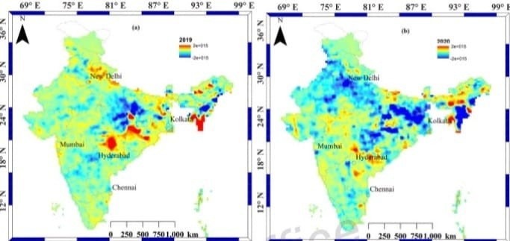In fig 4. Further, we have carried out a detailed analysis of NO2 concentration and plotted the temporal variations of tropospheric NO2 over five major cities for the month of March 2019 and 2020. In Delhi, an increasing trend of tropospheric NO2 is seen in 2019, whereas during 2020, a decline in tropospheric NO2 is observed. Soon after the total lockdown after March, a sharp decline in NO2 concentration is observed. In Kolkata, tropospheric NO2 concentration was almost the same as in the month of March 2019, but in the month of March 2020, a decline in concentration was observed. In Mumbai, in both years, 2019 and 2020, a decline in NO2 tropospheric concentration during March to April was observed, but due to lockdown, low tropospheric NO2 concentration was observed in the year 2020 compared with 2019. In Hyderabad, tropospheric NO2 concentration was also affected by lockdown; in March 2019, high values were observed compared with March 2020; a negative slope in the month of March 2020 shows a decline in tropospheric NO2 concentration due to lockdown. In general, in the month of 2020, concentration of tropospheric NO2 was lower during 2020 compared with March 2019. Chennai also shows a decline in tropospheric NO2 values during March 2020. Our results show lower values in tropospheric NO2 due to the lockdown over five US embassies located in major cities in India. In Delhi, Kolkata, and Chennai, a big contrast was observed during the lockdown periods compared with the same periods in 2019, whereas in Mumbai and Hyderabad, decline was not appreciable.

### *Fig.4*

Difference in Spatial variations of tropospheric NO2 over India for before and after concentration during (a) 2019 and (b) 2020

Figure-5:-

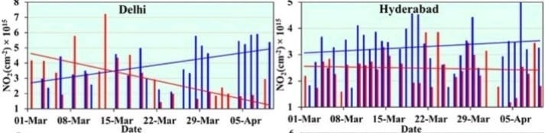*Temporal variations of tropospheric NO2 over US Consulate locations (Delhi, Mumbai, Chennai, Hyderabad, and Kolkata) in India during 1 March to 9 April 2020. The blue and red lines show a linear trend in average concentration of tropospheric NO2 during 2019 and 2020. Decreasing trend is seen in all cities, and in Delhi and Kolkata, contrast in trend is seen during 2019 and 2020.*

### *Fig.5*

Temporal variations of tropospheric NO2 over US Consulate locations (Delhi, Mumbai, Chennai, Hyderabad, and Kolkata) in India during 1 March to 9 April 2020. The blue and red lines show a linear trend in average concentration of tropospheric NO2 during 2019 and 2020. Decreasing trend is seen in all cities, and in Delhi and Kolkata, contrast in trend is seen during 2019 and 2020

# *Conclusion:-*

The lockdown appears to show pronounced improvement in air quality over these large densely populated metropolitan footprints of India where US embassies are located, but the lives of hundreds of millions of Indian people have been disrupted due to the lockdown in response to the COVID-19 pandemic. Our results show a pronounced decline in air pollutants during lockdown especially in Delhi and Kolkata; these two cities are known to be highly polluted cities in India and the world. The results will attract the attention of the Indian Government to ponder on how to strictly minimize vehicular and industrial pollution to improve air quality which will help to sustain better public health in India.

# *Acknowledgment:-*

The authors are grateful to Environmental Protection Agency (EPA) for providing PM2.5 and AQI data for five US Embassy in India. The authors also thank NASA Giovanni team for facilitating use of tropospheric NO2 satellite data. We are grateful to the two anonymous referees for their useful comments and suggestions that have helped us to improve earlier version of the manuscript.

# *Authors Contribution:-*

RPS and AC created the original study plan. RPS and AC designed and executed the study, AC carried out the analysis. RPS and AC wrote the original manuscript and both edited the final manuscripts. Both the authors read and approved the manuscript.

# *References:-*

1. Chandra BP, Sinha V, Hakkim H, Kumar A, Pawar H, Mishra AK, Sharma G, Garg S, Ghude SD, Chute DM, Pithani P. Odd-even traffic rule implementation during winter 2016 in Delhi did not reduce traffic emissions of VOCs, carbon dioxide, methane and carbon monoxide. Curr Sci. 2018;00113891:114(6). [Google Scholar]
2. Chauhan A, Singh RP (2017) Poor air quality and dense haze/smog during 2016 in the Indo-

Gangetic plains associated with the crop residue burning and Diwali festival. In2017 IEEE International Geoscience and Remote Sensing Symposium (IGARSS), 6048-6051.

1. Chauhan A, Singh RP (2020) Decline in PM2. 5 concentrations over major cities around the worldassociated with COVID-19. Environmental Research 109634. [PMC free article] [PubMed]
2. Krotkov NA, Lamsal LN, Marchenko SV, Celarier EA, Bucsela EJ, Swartz WH, Joiner J, OMI Core team (2019) OMI/Aura NO2 Cloud-Screened Total and Tropospheric Column L3 Global Gridded 0.25° x 0.25 ° V3, NASA Goddard Space Flight Center, Goddard Earth Sciences Data and

Information Services Center (GES DISC), Accessed:29/04/2020,10.5067/Aura/OMI/DATA3007.

1. Muhammad S, Long X, Salman M (2020) COVID-19 pandemic and environmental pollution: a blessing in disguise? Sci Total Environ 138820 [PMC free article] [PubMed]
2. Prasad AK, Singh RP, Kafatos M (2006) Influence of coal based thermal power plants on aerosol optical properties in the Indo-Gangetic basin. Geophys Res Lett 33 (5).
3. Raibhandari B, Phuyal N, Shrestha B, Thapa M (2020) Air medical evacuation of Nepalese citizen during epidemic of COVID-19 from Wuhan to Nepal. J Nepal Med Assoc 58(222). 10.31729/jnma.4857 [PMC free article] [PubMed]
4. Sarkar S, Singh RP, Chauhan A. Crop residue burning in Northern India: increasing threat to Greater India. J Geophys Res-Atmos. 2018;123(13):6920–6934. doi: 10.1029/2018JD028428. [CrossRef] [Google Scholar]